**说明**

1、程序使用Visual Studio 2019编写；

2、文本输入借助D盘根目录test.txt文件，已附在此压缩包中；

3、程序扩充了操作数集合、运算符集合，并引入了变量操作数；

4、栈的状态变化过程以步骤形式运行时打印在屏幕上，同时也显示了当前处理完成的部分表达式；

5、部分步骤中栈的状态没有明显变化，主要是由于此步骤处理的符号是空格；

6、栈状态显示可能步骤过多，特别是求值时栈内数据每变化一位都会打印一次，主要作调试使用。

7.程序源代码分为两部分，其一为要求1-4的实现，另一部分为要求5的实现，要求5实现部分仅支持正整数。

**测试数据与结果数据**

**第一部分 要求1-4的实现**

**测试数据：**

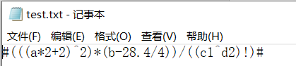

测试数据是自己设计的，主要目的是检测程序是否能完成对多层括号、简单加减乘除以及阶乘、乘方的处理。同时也检测程序是否能利用字符栈读取正数和负数、能否正确识别和替换变量操作数。

**程序运行展示：**

1、从文本文件读入并显示

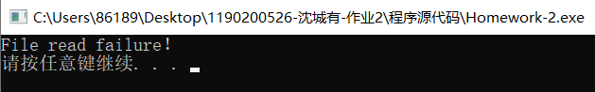

（读入失败显示）

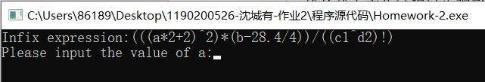

（读取成功后显示时自动略去‘#’，便于用户查看）

2、变量操作数识别与替换

（支持以大小写字母开头小于25长度的变量操作数，不超过10个）

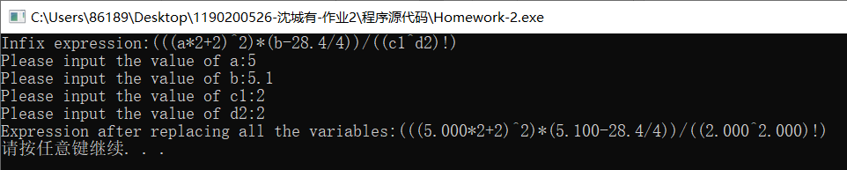

3、中缀表达式转换为后缀表达式

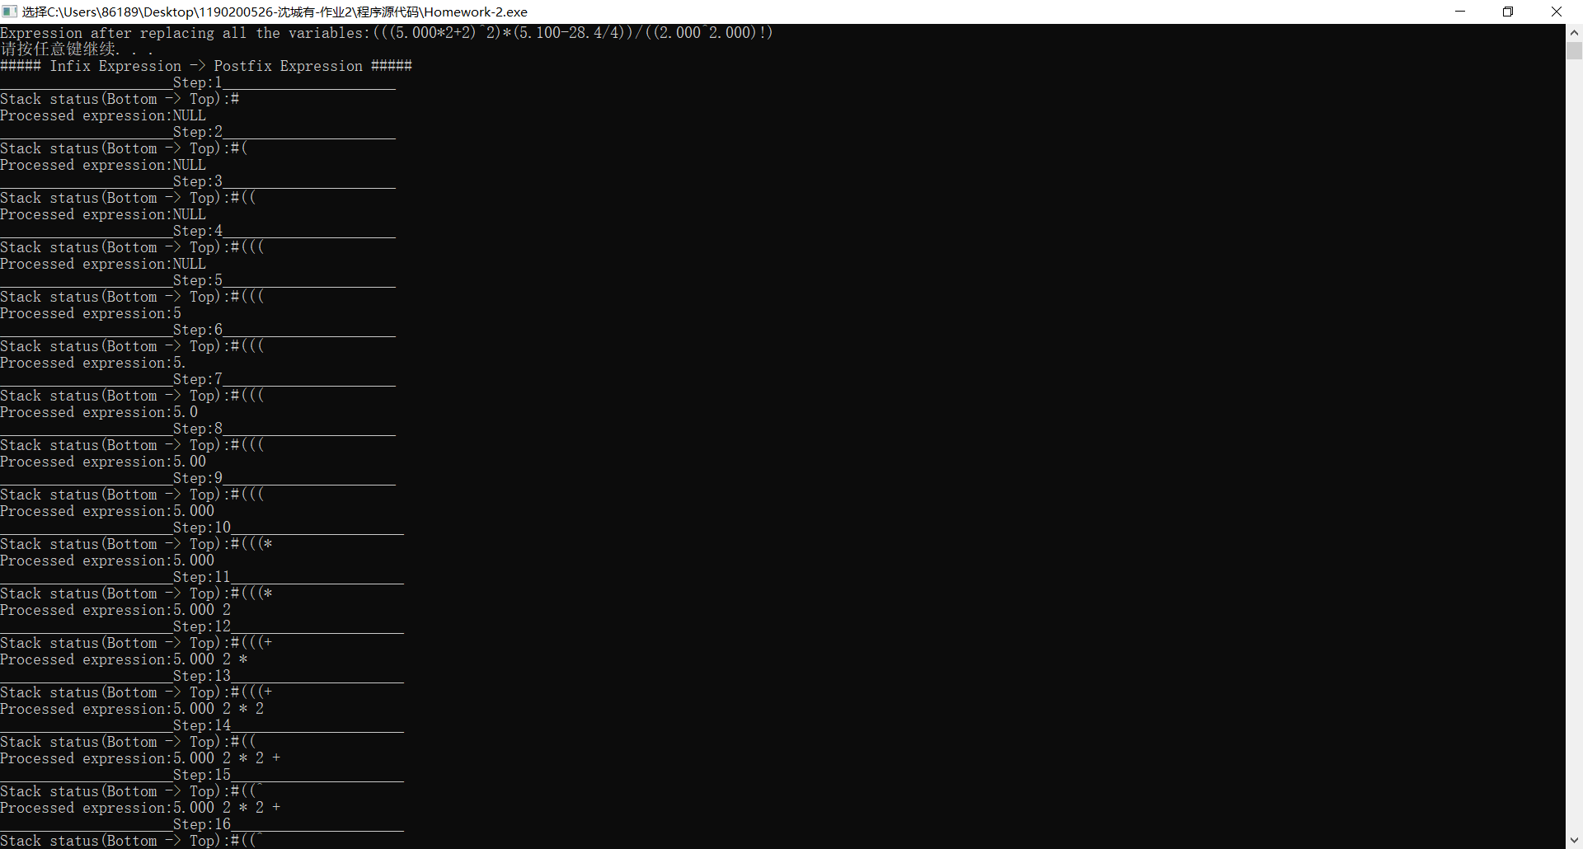

过程展示较长，以下以文本显示：

_____________________Step:16_____________________

Stack status(Bottom -> Top):#((^

Processed expression:5.000 2 * 2 + 2

_____________________Step:17_____________________

Stack status(Bottom -> Top):#(

Processed expression:5.000 2 * 2 + 2 ^

_____________________Step:18_____________________

Stack status(Bottom -> Top):#(*

Processed expression:5.000 2 * 2 + 2 ^

_____________________Step:19_____________________

Stack status(Bottom -> Top):#(*(

Processed expression:5.000 2 * 2 + 2 ^

_____________________Step:20_____________________

Stack status(Bottom -> Top):#(*(

Processed expression:5.000 2 * 2 + 2 ^ 5

_____________________Step:21_____________________

Stack status(Bottom -> Top):#(*(

Processed expression:5.000 2 * 2 + 2 ^ 5.

_____________________Step:22_____________________

Stack status(Bottom -> Top):#(*(

Processed expression:5.000 2 * 2 + 2 ^ 5.1

_____________________Step:23_____________________

Stack status(Bottom -> Top):#(*(

Processed expression:5.000 2 * 2 + 2 ^ 5.10

_____________________Step:24_____________________

Stack status(Bottom -> Top):#(*(

Processed expression:5.000 2 * 2 + 2 ^ 5.100

_____________________Step:25_____________________

Stack status(Bottom -> Top):#(*(-

Processed expression:5.000 2 * 2 + 2 ^ 5.100

_____________________Step:26_____________________

Stack status(Bottom -> Top):#(*(-

Processed expression:5.000 2 * 2 + 2 ^ 5.100 2

_____________________Step:27_____________________

Stack status(Bottom -> Top):#(*(-

Processed expression:5.000 2 * 2 + 2 ^ 5.100 28

_____________________Step:28_____________________

Stack status(Bottom -> Top):#(*(-

Processed expression:5.000 2 * 2 + 2 ^ 5.100 28.

_____________________Step:29_____________________

Stack status(Bottom -> Top):#(*(-

Processed expression:5.000 2 * 2 + 2 ^ 5.100 28.4

_____________________Step:30_____________________

Stack status(Bottom -> Top):#(*(-/

Processed expression:5.000 2 * 2 + 2 ^ 5.100 28.4

_____________________Step:31_____________________

Stack status(Bottom -> Top):#(*(-/

Processed expression:5.000 2 * 2 + 2 ^ 5.100 28.4 4

_____________________Step:32_____________________

Stack status(Bottom -> Top):#(*

Processed expression:5.000 2 * 2 + 2 ^ 5.100 28.4 4 / -

_____________________Step:33_____________________

Stack status(Bottom -> Top):#

Processed expression:5.000 2 * 2 + 2 ^ 5.100 28.4 4 / - *

_____________________Step:34_____________________

Stack status(Bottom -> Top):#/

Processed expression:5.000 2 * 2 + 2 ^ 5.100 28.4 4 / - *

_____________________Step:35_____________________

Stack status(Bottom -> Top):#/(

Processed expression:5.000 2 * 2 + 2 ^ 5.100 28.4 4 / - *

_____________________Step:36_____________________

Stack status(Bottom -> Top):#/((

Processed expression:5.000 2 * 2 + 2 ^ 5.100 28.4 4 / - *

_____________________Step:37_____________________

Stack status(Bottom -> Top):#/((

Processed expression:5.000 2 * 2 + 2 ^ 5.100 28.4 4 / - * 2

_____________________Step:38_____________________

Stack status(Bottom -> Top):#/((

Processed expression:5.000 2 * 2 + 2 ^ 5.100 28.4 4 / - * 2.

_____________________Step:39_____________________

Stack status(Bottom -> Top):#/((

Processed expression:5.000 2 * 2 + 2 ^ 5.100 28.4 4 / - * 2.0

_____________________Step:40_____________________

Stack status(Bottom -> Top):#/((

Processed expression:5.000 2 * 2 + 2 ^ 5.100 28.4 4 / - * 2.00

_____________________Step:41_____________________

Stack status(Bottom -> Top):#/((

Processed expression:5.000 2 * 2 + 2 ^ 5.100 28.4 4 / - * 2.000

_____________________Step:42_____________________

Stack status(Bottom -> Top):#/((^

Processed expression:5.000 2 * 2 + 2 ^ 5.100 28.4 4 / - * 2.000

_____________________Step:43_____________________

Stack status(Bottom -> Top):#/((^

Processed expression:5.000 2 * 2 + 2 ^ 5.100 28.4 4 / - * 2.000 2

_____________________Step:44_____________________

Stack status(Bottom -> Top):#/((^

Processed expression:5.000 2 * 2 + 2 ^ 5.100 28.4 4 / - * 2.000 2.

_____________________Step:45_____________________

Stack status(Bottom -> Top):#/((^

Processed expression:5.000 2 * 2 + 2 ^ 5.100 28.4 4 / - * 2.000 2.0

_____________________Step:46_____________________

Stack status(Bottom -> Top):#/((^

Processed expression:5.000 2 * 2 + 2 ^ 5.100 28.4 4 / - * 2.000 2.00

_____________________Step:47_____________________

Stack status(Bottom -> Top):#/((^

Processed expression:5.000 2 * 2 + 2 ^ 5.100 28.4 4 / - * 2.000 2.000

_____________________Step:48_____________________

Stack status(Bottom -> Top):#/(

Processed expression:5.000 2 * 2 + 2 ^ 5.100 28.4 4 / - * 2.000 2.000 ^

_____________________Step:49_____________________

Stack status(Bottom -> Top):#/(!

Processed expression:5.000 2 * 2 + 2 ^ 5.100 28.4 4 / - * 2.000 2.000 ^

_____________________Step:50_____________________

Stack status(Bottom -> Top):#/

Processed expression:5.000 2 * 2 + 2 ^ 5.100 28.4 4 / - * 2.000 2.000 ^ !

_____________________Step:51_____________________

Stack status(Bottom -> Top):

Processed expression:5.000 2 * 2 + 2 ^ 5.100 28.4 4 / - * 2.000 2.000 ^ ! /

Postfix expression:5.000 2 * 2 + 2 ^ 5.100 28.4 4 / - * 2.000 2.000 ^ ! /

最终处理得到的后缀表达式如上。

4、后缀表达式求值过程

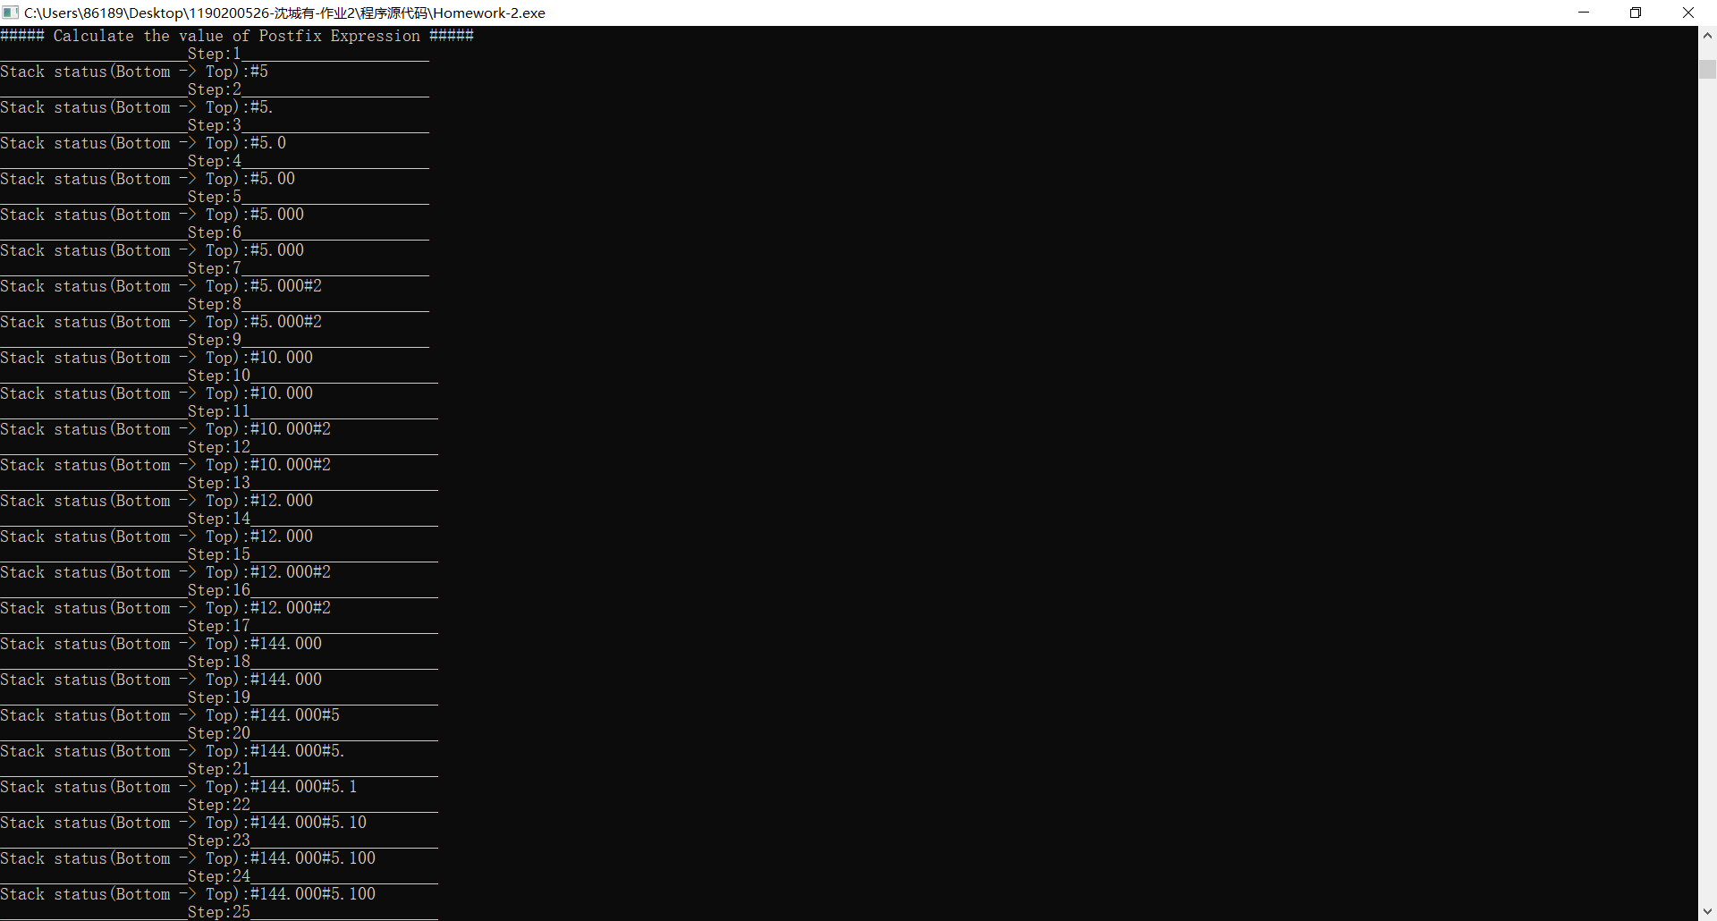

_____________________Step:25_____________________

Stack status(Bottom -> Top):#144.000#5.100#2

_____________________Step:26_____________________

Stack status(Bottom -> Top):#144.000#5.100#28

_____________________Step:27_____________________

Stack status(Bottom -> Top):#144.000#5.100#28.

_____________________Step:28_____________________

Stack status(Bottom -> Top):#144.000#5.100#28.4

_____________________Step:29_____________________

Stack status(Bottom -> Top):#144.000#5.100#28.4

_____________________Step:30_____________________

Stack status(Bottom -> Top):#144.000#5.100#28.4#4

_____________________Step:31_____________________

Stack status(Bottom -> Top):#144.000#5.100#28.4#4

_____________________Step:32_____________________

Stack status(Bottom -> Top):#144.000#5.100#7.100

_____________________Step:33_____________________

Stack status(Bottom -> Top):#144.000#5.100#7.100

_____________________Step:34_____________________

Stack status(Bottom -> Top):#144.000#-2.000

_____________________Step:35_____________________

Stack status(Bottom -> Top):#144.000#-2.000

_____________________Step:36_____________________

Stack status(Bottom -> Top):#-288.000

_____________________Step:37_____________________

Stack status(Bottom -> Top):#-288.000

_____________________Step:38_____________________

Stack status(Bottom -> Top):#-288.000#2

_____________________Step:39_____________________

Stack status(Bottom -> Top):#-288.000#2.

_____________________Step:40_____________________

Stack status(Bottom -> Top):#-288.000#2.0

_____________________Step:41_____________________

Stack status(Bottom -> Top):#-288.000#2.00

_____________________Step:42_____________________

Stack status(Bottom -> Top):#-288.000#2.000

_____________________Step:43_____________________

Stack status(Bottom -> Top):#-288.000#2.000

_____________________Step:44_____________________

Stack status(Bottom -> Top):#-288.000#2.000#2

_____________________Step:45_____________________

Stack status(Bottom -> Top):#-288.000#2.000#2.

_____________________Step:46_____________________

Stack status(Bottom -> Top):#-288.000#2.000#2.0

_____________________Step:47_____________________

Stack status(Bottom -> Top):#-288.000#2.000#2.00

_____________________Step:48_____________________

Stack status(Bottom -> Top):#-288.000#2.000#2.000

_____________________Step:49_____________________

Stack status(Bottom -> Top):#-288.000#2.000#2.000

_____________________Step:50_____________________

Stack status(Bottom -> Top):#-288.000#4.000

_____________________Step:51_____________________

Stack status(Bottom -> Top):#-288.000#4.000

_____________________Step:52_____________________

Stack status(Bottom -> Top):#-288.000#24.000

_____________________Step:53_____________________

Stack status(Bottom -> Top):#-288.000#24.000

_____________________Step:54_____________________

Stack status(Bottom -> Top):#-12.000

_____________________Step:55_____________________

Stack status(Bottom -> Top):#-12.000

Calculation Result:-12.000

计算结果如上，精确到三位小数。

**容错性测试（非整数阶乘）：**

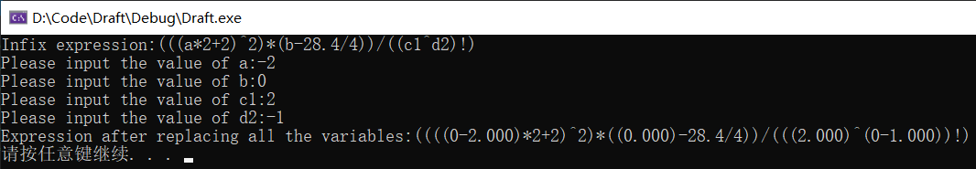

（无意义的1/2阶乘）

表达式处理正常

求值结果：

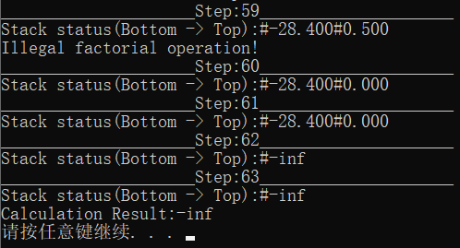

第59步检测到非法阶乘操作，最终输出结果为-inf。

**负号与减法运算符区分测试：**

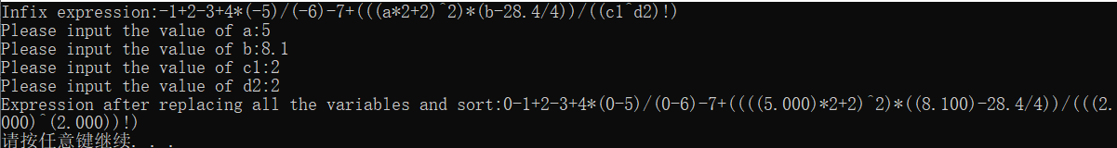

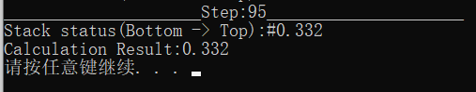

结果正确。

**第二部分 要求5的实现**

**测试数据：**

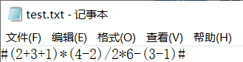（主要测试正整数加减乘除、括号处理）

**程序运行展示：**

